 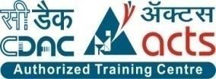

INSTITUTE FOR ADVANCED COMPUTING AND SOFTWARE DEVELOPMENT AKURDI, PUNE

Documentation On

**“PERSONAL PROJECT MANAGEMENT SYSTEM”**

PG-DAC MAY 2021

*Submitted By:*

**Group No: 40**

**Names & roll numbers**

RUCHADHAMDHERE 1047

AKANKSHA PATIL 1139

**Prashant Karhale Mr. Kashinath Patil**

**Centre Coordinator Project Guide**

# Table of Contents

Contents

Table of Contents 2

1. Introduction 4

Document Purpose 4

Problem Statement 5

Product Scope 5

Aims & Objectives 5

Overall Description 6

Specific Requirement 9

External Interface Requirements: 9

System Design 11

Use Case Diagram 16

ER Diagram 16

Conclusion 19

Future Scope 19

References 20

**List of Figures**

Figure 10 Use Case Diagram 16

Figure 11 ER Diagram 16

# Introduction

## To increase an efficiency of a product, nowadays many development companies are using different project management systems. A company may run a number of projects at a time, and requires input from a number of individuals, or teams for a multi level development plan, whereby a good project management system is needed.

## Project management systems represent a rapidly growing technology in IT industry. As the number of users, who utilize project management applications continues to grow, web based project management systems enter a critical role in a multitude of companies. Thus, a proper project management system plays a distinctive part in ensuring reliable, robust and high quality web applications for customers. Developing a project management system and showing how, in turns, it helps users to handle projects.

## Document Purpose

The main purpose to develop this project is to manage all the activities of the project development.

It manages all the project management, Task assignment, login management etc.

**Login Management**

One user can login at one time. Accessing your account is as easy as entering your username and password on the login screen or clicking one of our Single Sign-On options.

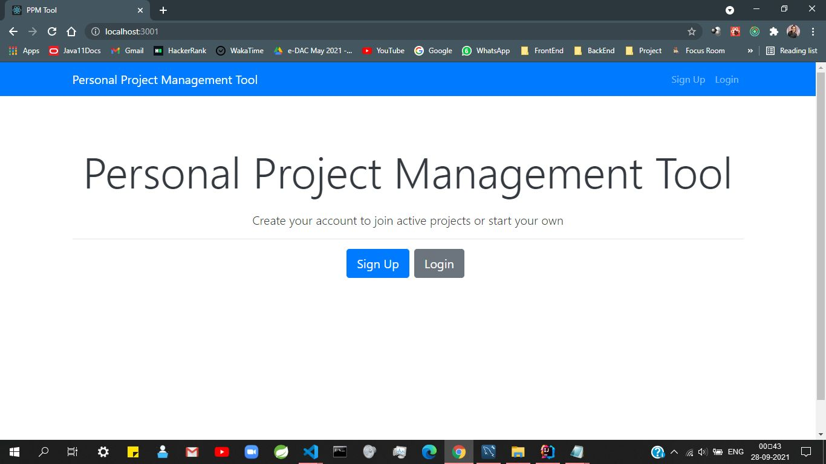

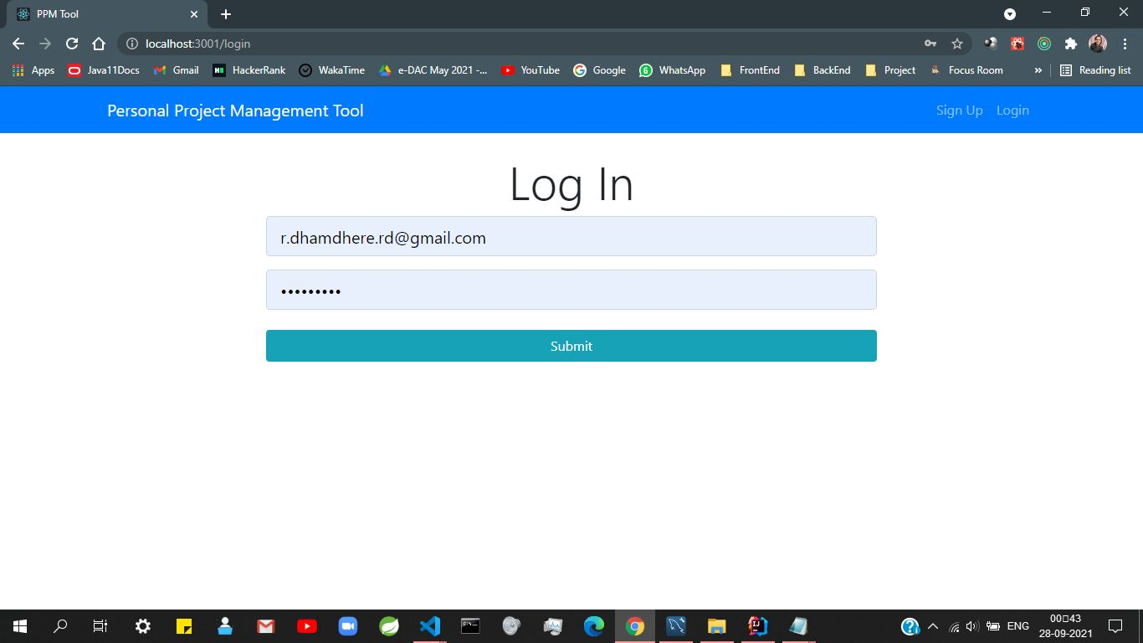

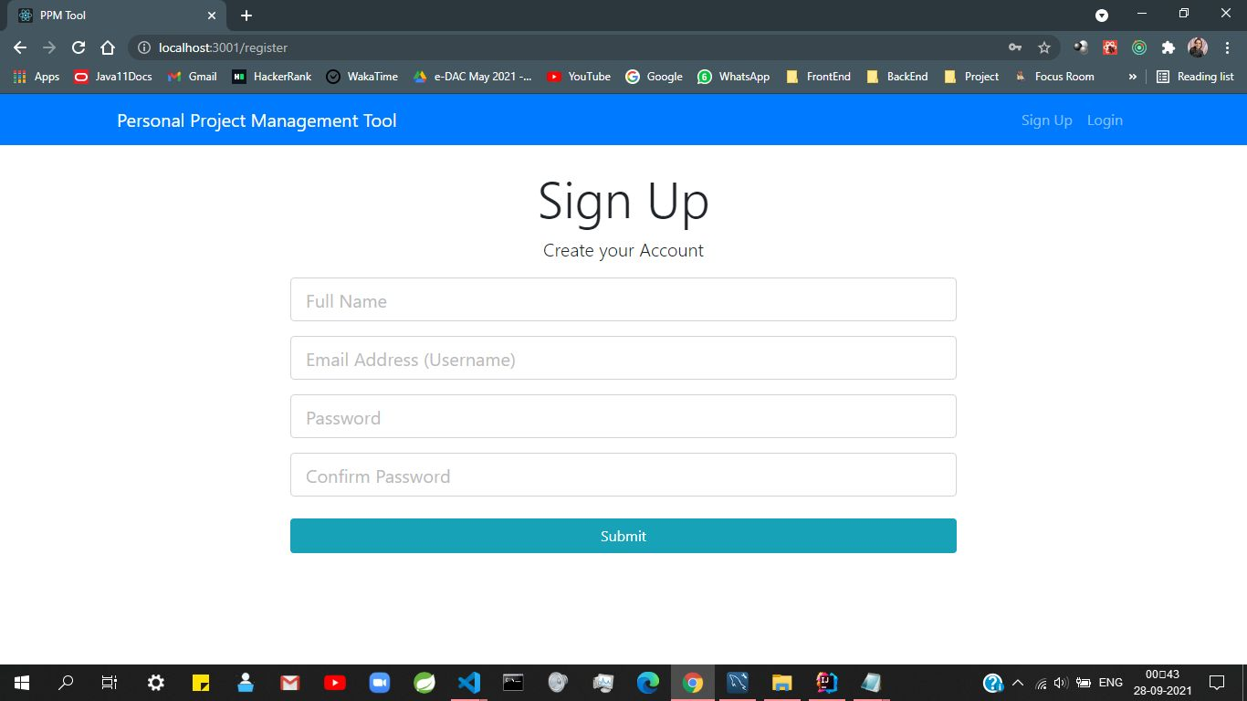

**Project management**

Project management is the process of planning, scheduling, resource management, requirement analysis, designing and testing to achieve project goals and objectives. Without project management it is difficult to complete projects in given time. Therefore, project management is required to remove such barriers in project development and to achieve specific goals.

You can add different projects and assign them different status.

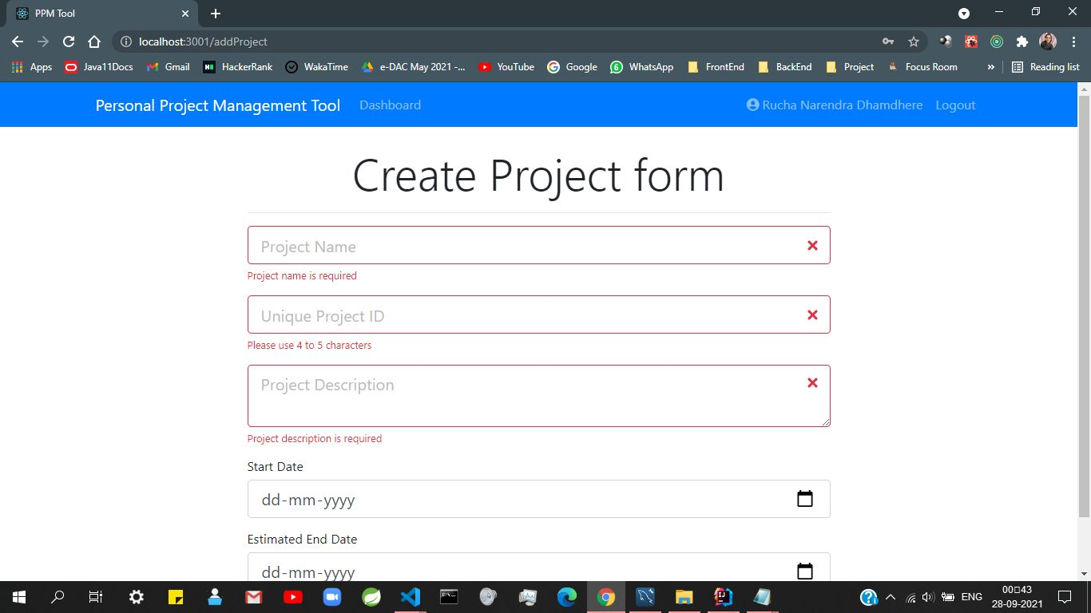

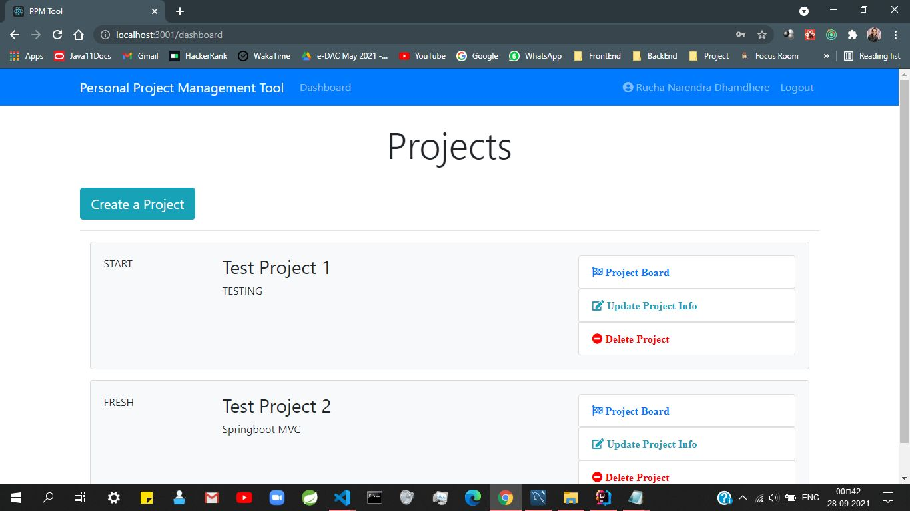

**Task assignment**

When you use task assignment, you assign activitiy to a project. Here we are going to assign specific task like to do, in progress, done to specific project.You can also view/update project information, delete project.

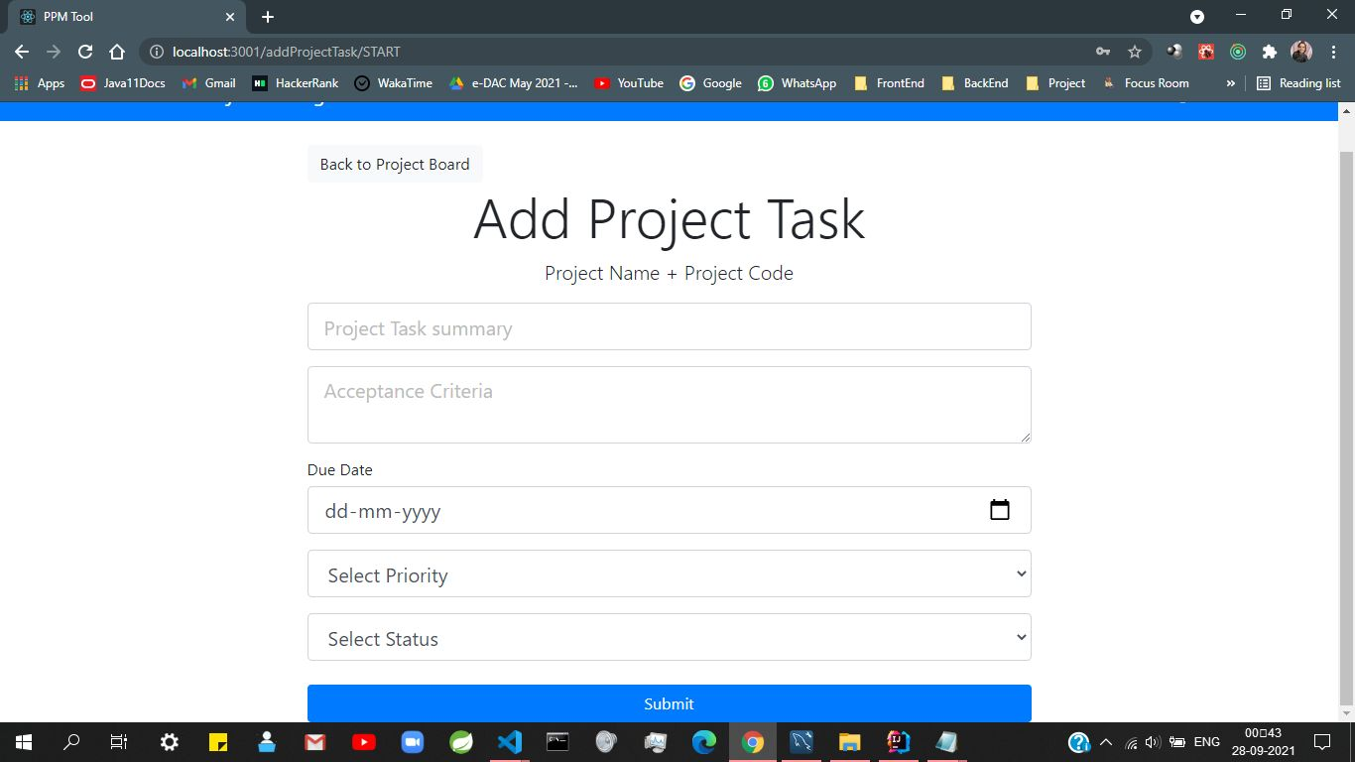

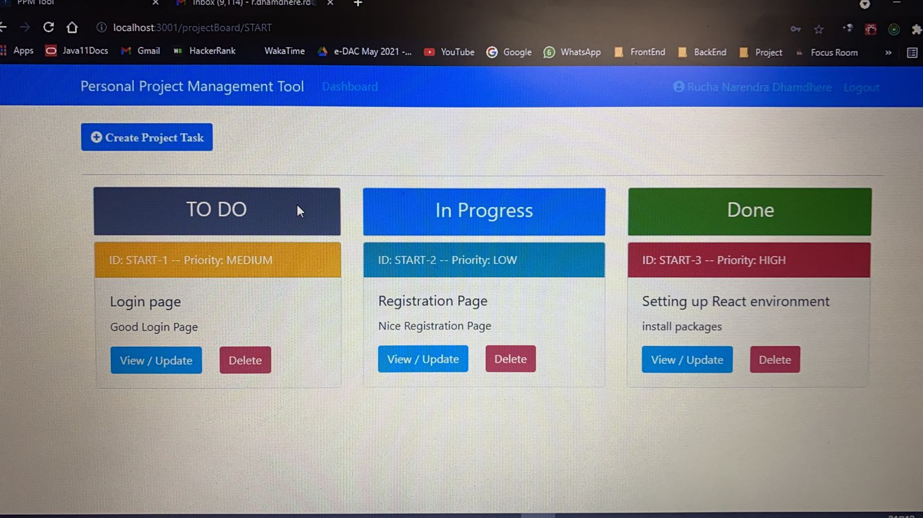

## Problem Statement

Existing system for a project is based on our traditional way keeping records and details on paper and registers. Access of these details and papers are not granted to common member in absence of the authority. It is hard to manage all the project system with pen and paper. It gets really hard to maintain the records and then keep track of past tasks. Hence this system is proposed to overcome the flaws of the existing system and giving power to the person so that he/she will be able to manage the project easily on personal level.

## Scope

This project traverses a lot of areas ranging from business concept to personal level, and required to perform several researches to be able to achieve the project objectives. The area covers include:

* General customers as well as the admin itself can will be able to use the system effectively for project management.
* REACT
* J2EE Technology used for the development of the application. Java 2 Enterprise Edition is a programming platform java platform for developing and running distributed java applications.
* HTML: Markup Language used for creating web pages.
* MySQL

The objective for collaboration has been: getting thing done faster, cheaper and better by applying their common knowledge, bringing together a selection of resources and attainments in a project.

## Aims & Objectives

In this project, we have build a Personal Project Management tool where the user can track his/her performance on multiple project at one place. This increases productivity. We have build our REST API's with spring boot 2.0 for curd operations. We created our frontend using REACT JS and Bootstrap. REDUX and Thunk to manage state of application in frontend. We secured our application using JWT tokens.

Specific goals are: -

* To produce a personal project management system that allow the user to add project and project realted tasks to it.
* To ease user by providing different tasks to it.
* To ease user to help him in his work to add and track tasks efficiently

# Overall Description

# For consuming necessary time, keeping all troubles less, and to organize all documents into one place and most importantly, to keep track of projects that are in production for customers or for keeping an eye on errors or mistakes that occur during the work process, then a good web based project management system was under consideration

## Benefits of Personal Project Management System

* This online personal project management system solution is fully functional and flexible.
* It is very easy to use.
* This online personal project management system helps on personal level as well as business level by standardizing the procedures.
* It saves a lot of time and work.
* Eco-friendly: The monitoring of the personal management and the overall business becomes easy and includes the least of paper work.
* The application acts as an office that is open 24/7.
* It increases the efficiency of the management at offering quality services to the users.
* It provides custom features development and support with the application.

# System Design

## Use Case Diagram

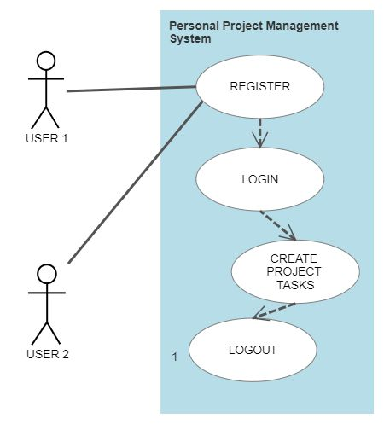

Figure 10: Use CaseDiagram

## ER Diagram

Figure 11: ER Diagram

**DATABASE:**

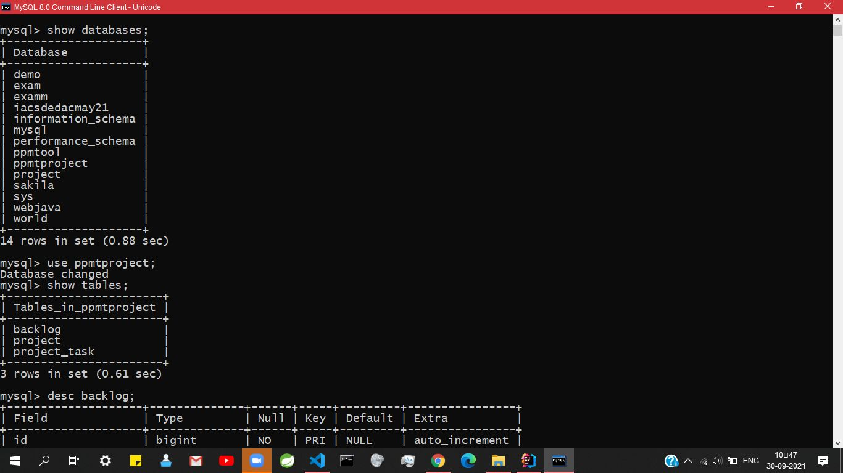

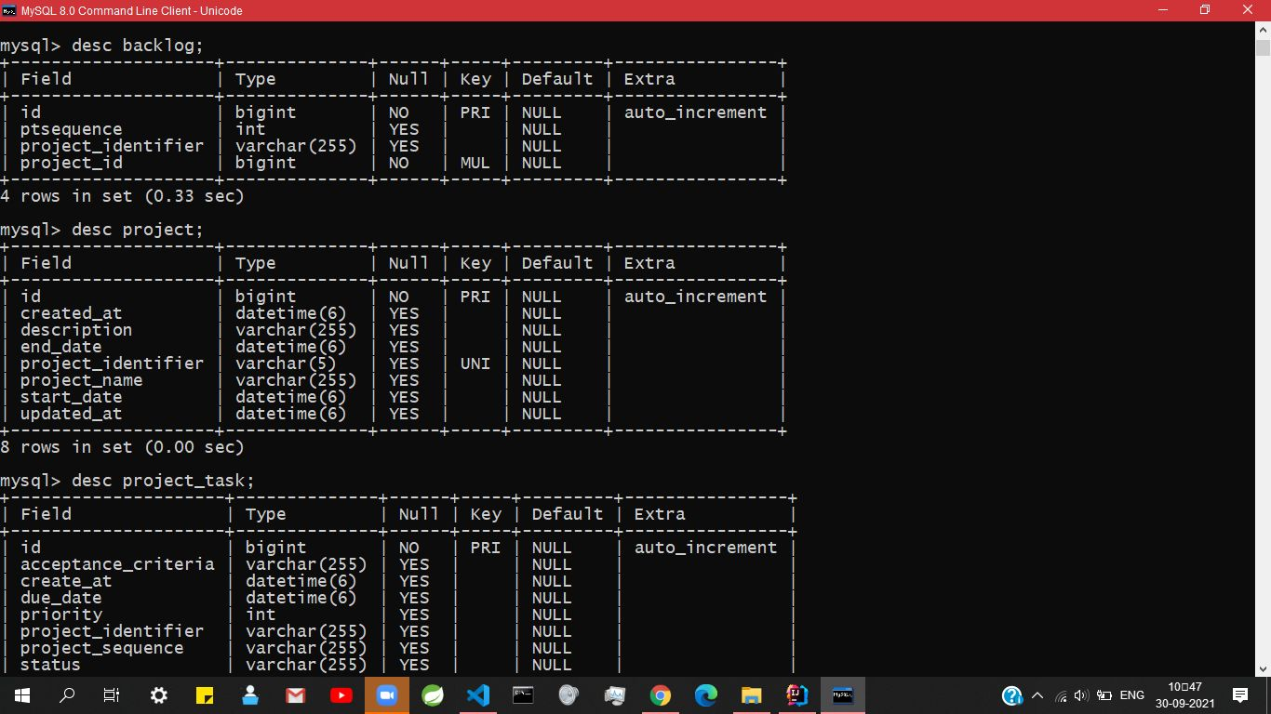

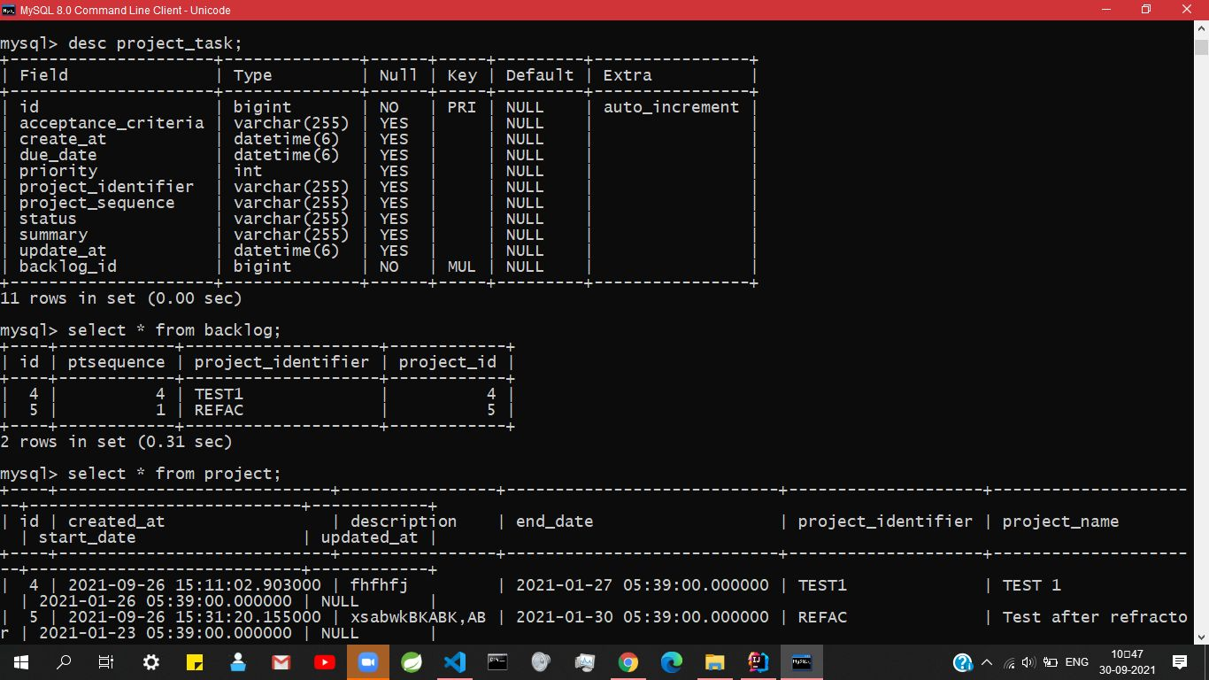

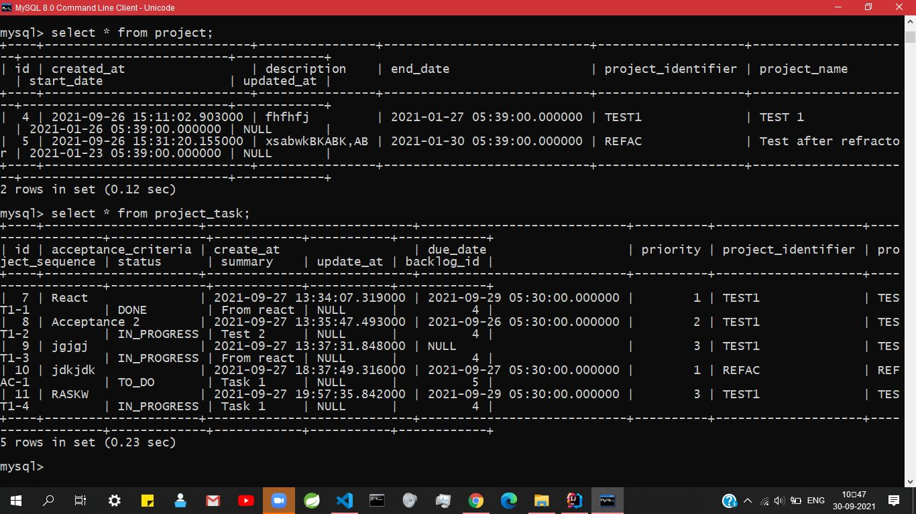

## 

# Conclusion

Society management system puts forth the actual working of a society. Administration, management, payment calculation, worker management, visitor management, etc. similar to a society are the key features of our project. User can access services and functionalities from the society anywhere and anytime for their own comfort.

# Future Scope

This project can be enhanced further by adding multiple users, online project system for the users to reduce the extra work of the admin. The software is flexible enough to be modified and implemented as per future requirements. We have tried our best to present this free and user–friendly website to users. Message and Email alerts for various happenings in the project can be added to the system so that users do not miss the updates and happenings of the society.

# 7.0 References

1. Software project management: from concept to deployment / Kieron Conway. Scottsdale (Ariz.) : Coriolis, c2001
2. Software project management / Bob Hughes and Mike Cotterell, London [etc.]: McGraw-Hill, c2002, 3rd ed.
3. Information systems project management: methods, tools and techniques / John McManus and Trevor Wood-Harper, Harlow [etc.] : Prentice Hall, c2003
4. [www.vidyarthiplus.com](https://www.vidyarthiplus.com/vp/attachment.php?aid=24322)

**ONLINE REFERENCE**

1. https://www.theseus.fi/bitstream/handle/10024/16996/Aadamsoo_Anne-Mai.pdf